Name: TANG Pok Man
SID: 59285726

The compiler is C++ 11, flag: -static -std=c++0x.

For all implementations, there is a phasing function (creatArray) and printing function (printAns) which both time complexity is O(n).
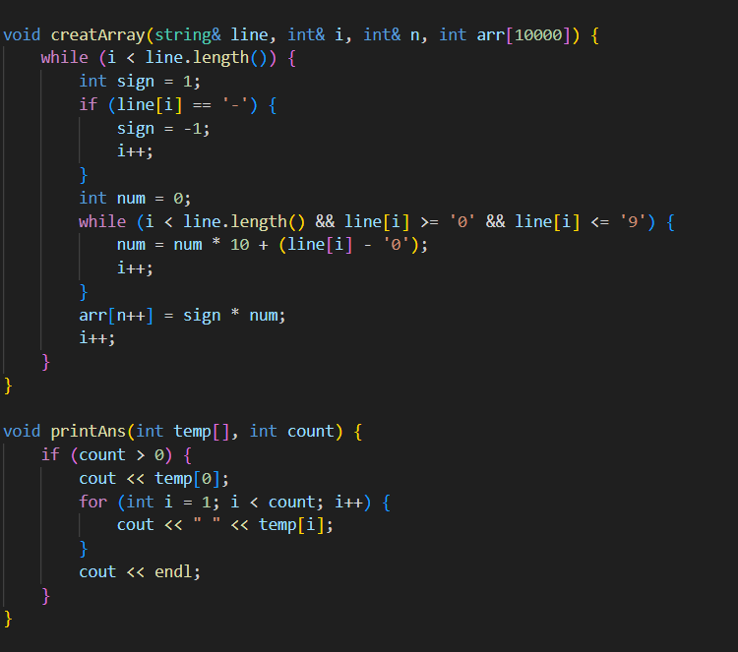
The first implementation is array based brute force approach. For this implementation, there is a nested for-loops to search whether there is duplicate of every number, so the time complexity is O(n^2). This is O(n^2) in worst case, even in average case, it's quadratic. If all elements are unique, it checks n(n-1)/2 pairs, and if all elements are same, it still O(n^2).
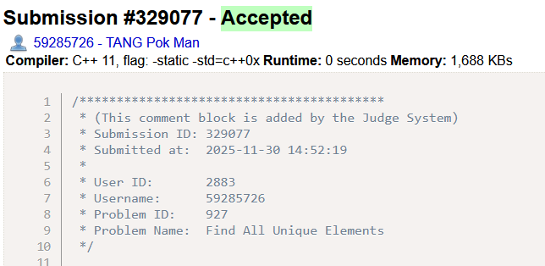
#include <iostream>
#include <string>
using namespace std;

void creatArray(string& line, int& i, int& n, int arr[10000]) {
while (i < line.length()) {
int sign = 1;
if (line[i] == '-') {
sign = -1;
i++;
}
int num = 0;
while (i < line.length() && line[i] >= '0' && line[i] <= '9') {
num = num * 10 + (line[i] - '0');
i++;
}
arr[n++] = sign * num;
i++;
}
}

void printAns(int temp[], int count) {
if (count > 0) {
cout << temp[0];
for (int i = 1; i < count; i++) {
cout << " " << temp[i];
}
cout << endl;
}
}

void findUnique(string line) {
int i = 0;
int n = 0;
int arr[10000];
int temp[10000];
int count = 0;
creatArray(line, i, n, arr);

bool visited[10000] = {false};
for (int j = 0; j < n; j++) {
bool repeated = false;
if (visited[j]) {
continue;
}
for (int k = j+1; k < n; k++) {
if (arr[j] == arr[k]) {
visited[k] = true;
repeated = true;
}
}
if (!repeated) {
temp[count++] = arr[j];
}
}
printAns(temp, count);
}

int main() {
string line;
getline(cin, line);
while (line != "") {
findUnique(line);
getline(cin, line);
}
return 0;
}
The second implementation is binary search tree. For this implementation, the time complexity of insert function and search function are O(n*log(n)) in average and the worst-case scenario is O(n^2). It would happen when the numbers are sorted and the tree becomes unbalanced and performs like a linked list.
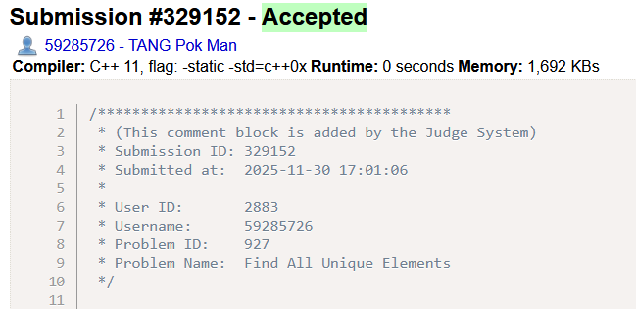
#include <iostream>
#include <string>
using namespace std;

class Node {
public:
int data;
Node* left;
Node* right;
int appear;
Node(int d) {
data = d;
left = nullptr;
right = nullptr;
appear = 1;
}
};

class Tree {
public:
Node* root;
Tree() {root = nullptr;}
void insert(int d);
void insert(Node* node, int d);
Node* search(Node* node, int d);
Node* search(int d);
};

void Tree::insert(int d) {
if (root == nullptr) {
root = new Node(d);
} else {
insert(root, d);
}
}

void Tree::insert(Node* node, int d) {
if (d < node->data) {
if (node->left == nullptr) {
node->left = new Node(d);
} else {
insert(node->left, d);
}
} else if (d > node->data) {
if (node->right == nullptr) {
node->right = new Node(d);
} else {
insert(node->right, d);
}
} else {
node->appear++;
}
}

Node* Tree::search(Node* node, int d) {
if (node == nullptr) {
return nullptr;
}
if (d < node->data) {
return search(node->left, d);
} else if (d > node->data) {
return search(node->right, d);
} else {
return node;
}
}

Node* Tree::search(int d) {
return search(root, d);
}

void creatArray(string& line, int& i, int& n, int arr[10000]) {
while (i < line.length()) {
int sign = 1;
if (line[i] == '-') {
sign = -1;
i++;
}
int num = 0;
while (i < line.length() && line[i] >= '0' && line[i] <= '9') {
num = num * 10 + (line[i] - '0');
i++;
}
arr[n++] = sign * num;
i++;
}
}

void printAns(int temp[], int count) {
if (count > 0) {
cout << temp[0];
for (int i = 1; i < count; i++) {
cout << " " << temp[i];
}
cout << endl;
}
}

void findUnique(string line) {
int i = 0;
int n = 0;
int arr[10000];
int temp[10000];
int count = 0;
creatArray(line, i, n, arr);

Tree myTree;
for (int i = 0; i < n; i++) {
myTree.insert(arr[i]);
}
for (int i = 0; i < n; i++) {
Node* node = myTree.search(arr[i]);
if (node->appear == 1) {
temp[count++] = arr[i];
}
}

printAns(temp, count);
}

int main() {
string line;
getline(cin, line);
while (line != "") {
findUnique(line);
getline(cin, line);
}
return 0;
}

The third implementation is linked list. For this implementation, the time complexity is O(n^2) since linked list can only search linearly. The worst-case scenario is when all numbers are unique, the function needs to travel the whole linked list for all numbers.
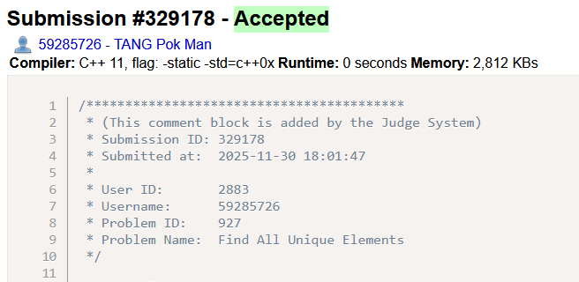
#include <iostream>
#include <string>
using namespace std;

class Node {
public:
int data;
int appear;
Node* next;
Node(int d, int a) {
data = d;
appear = a;
next = nullptr;
}
Node() {
data = 0;
appear = 0;
next = nullptr;
}
};

class List {
public:
Node* first;
Node allNode[10000];
int size;

List() {
first = nullptr;
size = 0;
}

Node* search(int d);
void insert(int d);
void temp(int temp[], int& count);
};

Node* List::search(int d) {
Node* curr = first;
while (curr != nullptr) {
if (curr->data == d) {
return curr;
}
curr = curr->next;
}
return nullptr;
}

void List::insert(int d) {
Node* newNode = search(d);
if (newNode == nullptr) {
if (first == nullptr) {
allNode[0] = Node(d, 1);
size++;
first = &allNode[0];
} else {
allNode[size] = Node(d, 1);
allNode[size-1].next = &allNode[size];
size++;
}
} else {
newNode->appear++;
}
}

void List::temp(int temp[], int& count) {
Node* curr = first;
while (curr != nullptr) {
if (curr->appear == 1) {
temp[count++] = curr->data;
}
curr = curr->next;
}
}

void creatArray(string& line, int& i, int& n, int arr[10000]) {
while (i < line.length()) {
int sign = 1;
if (line[i] == '-') {
sign = -1;
i++;
}
int num = 0;
while (i < line.length() && line[i] >= '0' && line[i] <= '9') {
num = num * 10 + (line[i] - '0');
i++;
}
arr[n++] = sign * num;
i++;
}
}

void printAns(int temp[], int count) {
if (count > 0) {
cout << temp[0];
for (int i = 1; i < count; i++) {
cout << " " << temp[i];
}
cout << endl;
}
}

void findUnique(string line) {
int i = 0;
int n = 0;
int arr[10000];
int temp[10000];
int count = 0;
creatArray(line, i, n, arr);

List* list = new List();
for (int i = 0; i < n; i++) {
list->insert(arr[i]);
}
list->temp(temp, count);

printAns(temp, count);
}

int main() {
string line;
getline(cin, line);
while (line != "") {
findUnique(line);
getline(cin, line);
}
return 0;
}

